33. Record Types - 07 July 2021

Salesforce Record Types allow us to specify a category of records that display different picklist values and page layouts.

OR

A Record type is used to control the picklist values and page Layouts.

Scenario : When a customer record is created for Car Loan , then Show Car loan Amount and Picklist (Financer) “Akash Cars, ABC Cars” for Car loan.

When a customer record is created for Home Loan , then Show Home loan Amount and Picklist (Financer) “Gruh Loan, Pyramid Loan” for Car loan.

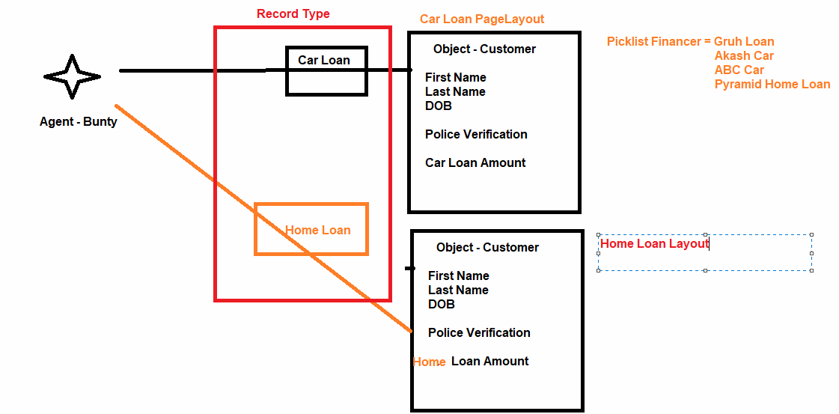

Scenario 2] When we create an Account record for “Saving Account”, then Show Type = “Prospect” and “Other”. And don’t show SLA, Active.

When we create an Account record for “Current Account”, then Show all the Type except “Prospect” and “Other”. And don’t show Rating.

Scenario : Record Type 🡪 Validation.

Saving Account 🡪 SIC Code should not be Blank 🡪 Error

